1.

$$-\frac{1}{r}\frac{d}{dr}\left(r\frac{du}{dr}\right)=1$$

By integration:

$$u=-\frac{1}{4}r^{2}+c_{1}\ln\left(r\right)+c_{2}$$

Plug in boundary: u(1)=0, u(2)=0,

$$c_{1}=\frac{3}{4ln2} , c_{2}=\frac{1}{4}$$

Finally,

$$u=-\frac{1}{4}r^{2}+\frac{3}{4ln2} \ln\left(r\right)+\frac{1}{4}$$

2.

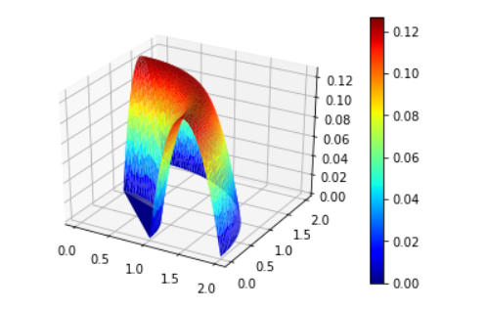

3.

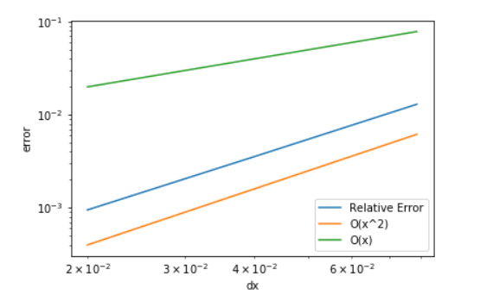

Define $dx=\sqrt{\frac{1}{ne}}$, I found that the convergence rate is second order.

When the order of Gauss Quadrature is no less than 2, the solution is stable, and the error will not have too much change. But, when the order is 1, the solution will become unstable (the plot below) and the error become very large (10^18 for fine mesh):

